**Zoned Out:**

**The Impact of Land Use Policy on Eviction Filings**

Prateek Wadhavkar[1]

Winter 2023

*Submitted on February 5th, 2023*

**Abstract**

I examine the effects of restrictiveness in land use policy on the rates of eviction filings at the county level. Land use policy is defined as the policy framework of a jurisdiction guiding land acquisition, allocation, utilization, and consumption. The restrictiveness of land use policy is the degree to which it affects housing supply elasticity. I investigate the relationship between county-level changes in land use policy on the changes in the eviction filings rate between the mid-2000s and late 2010s. I find that a 1 standard deviation increase in the Land Use Restrictiveness Index increases the eviction filings rate by 41 (p=0.013) per 100,000 of the population. I find a similar relationship between a variety of other land use policy related indices and variables, including the legality of mobile homes, the number of local regulatory bodies with veto power on zoning reforms and the amount of previously undeveloped land in which housing construction is allowed.

**Introduction**

The United States has a high rate of eviction compared to other developed countries, with an estimated 2.3 million evictions being filed, and 900,000 evictions occurring each year.[2] In 2016, 6.1% of all renters in the United States faced eviction procedures, with 2.3% of households receiving court eviction orders. Both figures are the highest out of all OECD countries by a large margin. Evictions can have severe consequences for individuals and families. Eviction can lead to destabilization, homelessness, and negative impacts on health and well-being. When individuals are evicted, they may lose access to their social networks, support systems, and other resources, which can lead to difficulty finding new housing and a higher risk of homelessness.[3] The process of being evicted can be stressful and disruptive, which can have negative effects on physical and mental health.[4] In terms of financial consequences, eviction can lead to increased expenses, such as the costs of moving and finding new housing, as well as potential legal fees. Additionally, eviction can lead to a loss of income, as individuals may miss work or lose their jobs due to the disruption caused by the eviction process. This can lead to financial instability and difficulty making ends meet. [5] Hence, evictions lock families and individuals in a self-perpetuating cycle of poverty.[6]

While the rate of eviction filings and eviction court orders has stayed roughly constant between 2000 and 2019, the proportion of income poor families spend on housing has steadily increased.[7] About half of all poor families spend more than 50% of their income on housing related costs.[8] This puts a significant proportion of families at higher risk of eviction. Hence, given the prevalence and pervasiveness of evictions in American society, it is crucial to understand the factors that contribute to eviction in order to develop effective policies and interventions to prevent it.

Empirical studies examining causes of eviction have identified that women are significantly more likely than men to experience evictions. Rates of eviction also differ significantly based on racial and ethnic differences- black and Hispanic renters are more likely to face evictions.[9] Low educational attainment is positively correlated with the rates of eviction.[10] [11] Studies analyzing the role played the housing market have found that housing rents and local unemployment rates are positively associated rates of homelessness and eviction,[12] and that higher rents are also associated with longer periods of homelessness among the already homeless.[13] Landlord-tenant laws, which outline the duties of landlords and tenants in residential contract leases, also have a significant impact on rates of eviction. States with tenant-friendly laws, which make it more difficult for landlords to evict tenants, have lower rates of eviction compared to states with landlord-friendly laws.[14]

One factor that has received relatively little attention in the literature on eviction is land use policy. Land use policy refers to the regulations and guidelines that govern how land can be used in a jurisdiction. These policies can vary widely and may be enacted at the local, state, or federal level. However, in the United States, most aspects of land use policy are left at the local level. As a result, we observe a high degree of variance in land use policy from one jurisdiction to another. We can exploit this variation to assess the impacts of various land use policy related decisions.

Land use policies can cover a wide range of issues, including zoning regulations, the allocation of public land, and the development of affordable housing. Zoning laws can specify what types of buildings or activities are allowed in certain areas, such as residential, commercial, or industrial use. These regulations can also specify the density of development, the height and size of buildings, and other characteristics. They determine the proportion of housing projects that get approved, the duration of the approval process and the various fees associated with this process. These regulations also determine whether mobile homes are legal in the jurisdiction. The allocation of public land is another aspect of land use policy. This refers to the decision-making process around how public land, such as parks or open spaces, is used and managed. Public land can be used for a variety of purposes, including recreation, conservation, and development. Land use policy also plays a role in the development of affordable housing. For example, policies may encourage or require the inclusion of affordable units in new developments or provide incentives for the construction of affordable housing.

Inclusive zoning refers to policies that aim to create more diverse and integrated communities by promoting the development of affordable housing in areas that are traditionally more expensive or exclusive. These policies can take a variety of forms, including requirements for a certain percentage of units in new developments to be designated as affordable, incentives for developers to build affordable housing, and other measures. Inclusive zoning policies are often implemented at the local level and can be seen as a way to address issues of housing segregation and affordability in a community. Inclusive zoning policies have been implemented in several cities and states around the United States and have received both support and criticism. Some argue that inclusive zoning is an important tool for promoting diverse and integrated communities,[15] while others argue that it can lead to unintended consequences, such as decreased housing.[16] Overall, the effectiveness of inclusive zoning as a policy tool is a topic of ongoing debate and research.

The restrictiveness posed by the regulatory environment is difficult to measure as there are several different ways in which land use policy may affect housing supply. For instance, some jurisdictions could place a hard cap on residential housing density, or the number of housing permits issued. However, jurisdictions could also influence housing supply indirectly by raising costs by increasing approval waiting periods, imposing design restrictions, and charging impact fees. Hence, to evaluate the effects of land use policy, we need to consider a variety of variables. In summary, land use policies can shape the availability and affordability of housing. As evictions are primarily caused due to evicted families and individuals not being able to afford the cost of housing, economic intuition suggests that land use policy may affect rates of eviction.

In this research paper, I seek to explore the impact of land use policy on the rates of eviction at the county level. My dependent variable will be the change in rates of eviction filings between 2007 and 2017, and my independent variable will consist of a matrix of values indicating a change in different facets of land-use policy during this period. This matrix will include variables such as the maximum density requirements, the legality of mobile homes, the existence of impact fees, the existence of affordable housing laws, the level of political involvement in zoning policy and housing permit approval at the local level, and whether single and multi-family homes can be built on undeveloped land. This matrix will also contain indices indicating the level of local and state-level involvement in project approval, the extent of affordable housing laws, and a variable evaluating the overall restrictiveness of the housing regulatory environment.

We will use a change-on-change approach to investigate whether the change in restrictiveness of land use policy is correlated with a change in the rates of eviction across counties. The main advantage of this model is that we have complete control over time-invariant confounders.

By examining the relationship between land use policy and eviction rates, this research aims to shed light on the potential role of land use policy in addressing the eviction crisis in the United States. Such information could inform the development of more effective policies and interventions to prevent eviction and promote housing stability for low-income renters.

**Evidence on the Relationship Between Land Use Policy and Evictions**

There is limited literature examining the effects of land use policy on rates of eviction. This is in part due to a limited availability of eviction and land use data until very recently. The only other paper directly exploring this relationship is *Land Use Regulations, Housing Supply, and County Eviction Filings (2022)* by Casey Dawkins. [17] This research uses land use data from the Wharton Residential Land Use Restrictiveness Index and the Eviction Lab’s Eviction Tracking System to study the relationship between land use policy and eviction rates at a cross-sectional level for the years between 2009 and 2016. Dawkins observes a positive correlation between restrictive land use regulations increase eviction filing rates. The study also finds that elastic housing supply and inclusionary zoning reduce eviction filing rates. The study also finds that pro-renter state landlord-tenant laws have no effect on eviction filing rates. Casey argues that the best strategy to reduce evictions likely combines several policy tools, including land use reforms to increase housing supply and inclusionary zoning policies, as well as government-subsidized housing programs. As this paper conducts a cross-sectional study, it is unable to measure the correlation between an increase or decrease in restrictiveness of land use policy on the change in eviction rate. This study also only uses two independent variables- the restrictiveness index and inclusionary zoning. Hence, it is unable to observe correlations between subtle policy decisions and eviction filings.

Another study by Maria Hanratty in 2017, *Do Local Economic Conditions Affect Homelessness?[18]*, examines the relationship between homelessness and housing and economic conditions in the United States. While this study examines homelessness and not evictions, we can draw inferences from this study that extend to evictions. This is due to a strong correlation between regions with high rates of eviction and regions with high rates of homelessness. The results suggest that area-level homeless rates are strongly correlated with both housing market conditions and poverty rates. The study also found that the relationship between poverty and homelessness may have strengthened in recent years. The study has several limitations, including possible inconsistencies in the way that communities measure homelessness over time and the possibility of downward bias due to sampling error in estimated community-level characteristics. Nevertheless, it offers policy relevant insights on how to reduce rates of homelessness.

As we have previously discussed, evictions take place because individuals and families are priced out of being able to afford shelter. This suggests a potential relationship between rising housing prices and evictions. Gyourko and Glaeser, in T*he Economic Implications of Housing Supply[19]* causally examine the effects of land use policy on the prices of homes. The authors employ a cost-based approach to assess whether housing prices in a given market are appropriate, based on the production cost of a housing unit. They classify US housing markets into three groups: lightly regulated markets with growing populations and economies, heavily regulated markets with growing economies, and markets with declining demand. The authors argue that regulatory construction constraints can lead to higher ratios of housing prices to minimum profitable production costs in some markets, similar to how capital adjustment costs can lead to higher ratios of market value to firm replacement cost in classical investment models. Hence, they are able to effectively prove the effects of strictly regulated housing policy on higher housing costs.

In this paper, I hope to tie in the inferences of all three of these papers. I hypothesize that an increase in land use policy restrictiveness is correlated with an increase in the eviction filings rate. My economic intuition here is that as land use policy becomes more restrictive, housing supply becomes more inelastic. Hence, as demand for housing increases due to an increase in population, economic growth and urbanization, housing prices would also increase at a higher rate. This would result in more families being priced out of housing, increasing the rate of eviction. Hence, I would predict that counties adopting more restrictive land use policies will, on average, observes a higher increase in eviction filings. The following flow chart illustrates this intuition:

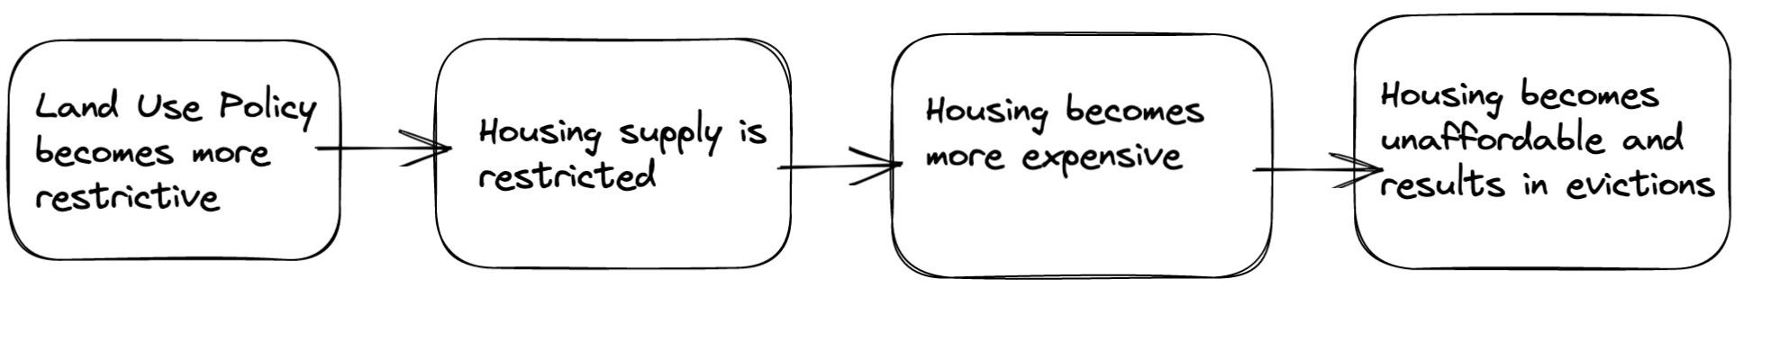

**Data**

In my empirical analysis, I examine the impact of land use restrictions on the rates of eviction in urban counties across the United States. I am using the National Longitudinal Land Use Survey and the Wharton Residential Land Use Survey to quantify various facets of land use policy. I using data from the Eviction Tracking System from the Eviction Lab for annual rates of eviction across US counties. Additionally, I use data from the American Community Survey to generate my controls. The summary statistics for my data are available under table 1.

The National Longitudinal Land Use Survey is a dataset designed to collect data from local governments about land use policies. This cross-sectional dataset was developed by the Urban Institute and Fannie Mae, and was administered in 1993, 2003 and 2019. Topics covered by this dataset include regional zoning density, impact fees, growth management techniques, adequate public facility ordinances and affordable housing policies and programs. For the years 2003 and 2019, it includes jurisdictions from the 50 most populous core-based statistical areas. The unit of observation in this dataset is a land use jurisdiction- a local government with land-use planning authority. The area covered by a land use jurisdiction is always smaller than that of a county. However, each jurisdiction does not always map neatly onto a census tract or county subdivision. This survey was sent out to land use planning officials in each selected jurisdiction. The 2003 survey was emailed to 2365 jurisdictions and received responses from 1845 jurisdictions. The 2019 survey was sent out to 2945 eligible jurisdictions and received replies from 1703 jurisdictions. Across the 2003 and 2019 datasets, we observe 1034 repeat respondents, which corresponds to 362 counties.

I estimate the values of land use policy variables for each county by calculating the population weighted means of all jurisdictions within a given county. I am unable to assess the percentage of jurisdictions represented within a county Within this dataset I am particularly interested in the variables for maximum density, the legality of mobile homes, the presence of impact fees, whether inclusionary zoning is mandated, and whether an affordable housing trust fund has been constructed. In addition to these variables, the 2019 dataset includes retrospective questions asking planners whether the density, magnitude and legislation surrounding single-family and multi-family housing has changed.

The Wharton Residential Land Use Survey was conducted in the years 2018 and 2006. This dataset aims to measure the level of regulatory restrictiveness against new housing in each urban land use jurisdiction. The Wharton Residential Land Use Regulatory Index, or the Wharton Index for short, measures regulatory restrictiveness by considering multiple variables, such as local political pressure, local court involvement, housing supply restrictions and housing density restrictions. Each of these factors are also computed as individual sub-indices. These indices are calculated on the basis of a questionnaire answered by planners in each land use jurisdiction. An advantage posed by this dataset compared to the Urban Institute dataset is that it has a more holistic measure of land use restrictiveness. A key reason it is so difficult to accurately measure the restrictiveness of the local regulatory environment is because there are many ways that regulation can affect supply. The most direct mechanism is via a hard cap on permitting or building of new housing units, which the Urban Institute dataset measures. However, communities also can influence supply in indirect ways by enacting policies that raise costs via delay in evaluating project proposals, imposing expensive design or density restrictions. By accounting for political pressure and the level of local involvement in land use policy, this index paints a more detailed picture of land use restrictiveness. Here, a higher value indicates a greater level of regulation. This index has been standardized.

Map 1 visualizes the Wharton Index across counties across the United States for the year 2006. Map 2 does the same for the year 2017. Most notably, in both of these maps, we can observe that New England states have some of the most restrictive land use policies in the country. On the other hand, Texas, and most midwestern states have the least restrictive land use policies. Map 3 visualizes the change in land use restrictiveness. We can observe that cities such as Boston, Chicago, Minneapolis, Pittsburgh and Detroit have generally become less restrictive, whereas cities such as Raleigh, Portland, Miami, Dallas, Charleston and Reno have become more restrictive.

I use the Eviction Lab’s Eviction Tracking System to generate eviction-related data at the county level. The eviction tracking system contains the number of eviction filings for several counties, zip codes and census tracts. The Eviction Lab team has collected this information by counting publicly available eviction records and corroborating these records with data published by county and state systems. Counties for which eviction data could not be verified are given null values. The eviction filings rate per 100,000 is calculated using the county population from the American Community Survey. I use the 2007 and 2017 values to calculate the difference in eviction filings rate for each county in my model.

The Eviction Tracking System does not have data available for all counties for the years 2007 and 2017. I only have data available for most counties in 22 states, and metropolitan areas in 5 other states for both years. Map 4 shows the distribution in eviction rates across counties in 2007, and map 5 shows the same distribution for 2017. We can observe an unequal spread in eviction filings rates across the countries. Southern states such as Georgia and North Carolina, and metropolitan regions in New Jersey, Maryland, Texas and Michigan have some of the highest rates, whereas New England, the Pacific Northwest, Hawaii and the great plains observe some of the lowest rates. Map 6 shows the difference in eviction rates over the 10-year period. Here, we can observe a general increase in eviction rates in rural and suburban counties.

**Independent Variables of Interest**

The NLLUS contains two types of variables. The first type is present in both, the 2003 as well as 2019 versions of this dataset. These include the maximum density requirements, which indicate the maximum residential units per unit area that can be built in a jurisdiction, the legality of mobile homes, whether impact fees are charged, whether affordable housing incentives are offered, and whether an affordable housing funding mechanism, like a trust fund, is in place. The final variable in this category indicates whether a permit could be granted to a hypothetical housing plan involving the construction of 40 units of two-story apartments on a 5-acre parcel. Maximum density requirements are measured in terms of residential permits that can be issued per acre. The legality of mobile homes is a Boolean variable- 1 indicates that mobile homes are legal, and 0 indicates that mobile homes are not legal. The variable measuring impact fees is also a Boolean variable, with 1 indicating that impact fees are charged, and 0 indicating that no impact fees are charged. Variables for whether a county has an affordable housing funding mechanisms or mandates affordable housing policies are also Boolean.

The second type of variable is only present in the 2019 dataset. These variables are indicative of responses to retrospective questions asking urban planners about the nature of changes in the previous 10-15 years. These responses are answered with a number between 1 and 3. 1 indicates a general decrease, 2 indicates things remaining the same, and 3 indicates a general increase. Retrospective questions in my dataset include the following. How has the amount of land where single family homes can be constructed changed? What is the change in undeveloped land where single family homes can be constructed? What is the change in permitted density for single family homes? How has the amount of land where multi family homes can be constructed changed? What is the change in undeveloped land where multi family homes can be constructed? What is the change in permitted density for multi family homes? How have fees required for a housing permit changed? How has the amount of time required to process a residential development application changed? The values for these variables, as well as the Boolean variables mentioned earlier, are discrete in the original NLLUS datasets. However, as my dataset is comprised of weighted means of the county subdivisions that are contained in each county, these values will be treated as continuous in my model.

The Wharton Residential Land Use Regulatory Index is calculated using eleven subindices, which themselves are calculated on the basis of urban planners’ responses to 15 questions. I will be including 6 out of these 11 sub-indices in my model. The sub-indices I will be using are as follows. The Local Zoning Approval Index (LZAI) is based on responses to a question regarding which organizations or regulatory bodies have to approve any request for a zoning change. The question listed six groups ranging from a local planning commission to an environmental review board. The LZAI is the simple sum of the number of entities whose approval is required. The Supply Restrictions Index (SRI) reflects the extent to which there are explicit constraints or caps on supplying new units to the market. This index is constructed based on responses to questions involving fixed restrictions on housing supply. Some examples of these restrictions include the number of single family or multi family homes authorized for construction, or the maximum number of units allowed in a multi family home. This index is a simple sum of these restrictions. The Density Restrictions Index (DRI) measures density restrictions in jurisdictions based on the largest minimum lot size requirements. The values for DRI can range from 0 to 4, depending on the extent of the restrictions in place. 0 implies that there are no density restrictions and is suggestive of the least restrictive land-use policy, and 4 implies that the largest minimum lot size is larger than 2 acres, which is suggestive of the most restrictive land use policy. The Extractions Index (EI) is a boolean variable which equals 1 when developers are required to pay some type of impact fee, or an allocable share of the cost of infrastructure. The Open Space Index (OSI) is also a boolean variable, which equals 1 when a jurisdiction imposes a mandatory open space provision. The Approval Delay Index (ADI) measures average duration of the review process, the typical amount of time between application for rezoning and issuance of a building permit for hypothetical projects, and the typical amount of time between application for subdivision approval and the issuance of a building permit conditional on proper zoning being in place. This subindex can be interpreted as the average time lag in months.

The other sub-indices that are used to calculate the index but are not included in my analysis are as follows. The Local Political Pressure Index (LPPI) is calculated to reflect the degree of involvement by various local actors in the development process. This index is affected by the number of local entities and their level of importance. The State Political Pressure Index (SPPI) is calculated to reflect the degree of involvement by various state actors in the development process. It is a standardized sum of two components. The first component is based on the fifty state profiles of state-level legislative and executive branch activity pertaining to land use regulation developed by Foster and Summers (2005). The second component is calculated based on a response to a survey question, “how involved is the state legislature in affecting residential building activities and/or growth management procedures?” The State Court Involvement Index (SCII) reflects the degree of deference to municipal control, with a score of 1 implying that the courts have been highly restrictive regarding its localities’ use of these municipal land-use tools. This index is also calculated using values form the Foster and Summers (2005) and is based on the tendency of appellate courts to uphold or restrain four types of municipal land-use regulations -- impact fees and exactions, fair share development requirements, building moratoria, and spot or exclusionary zoning. The Local Assembly Index (LAI) is a measure of direct democracy and captures whether there is a community meeting or assembly before which any zoning or rezoning request must be presented and voted up or down. This subindex takes on a value of one if the community both has a regular town meeting and a requirement for a popular vote in order to approve changes to zoning regulations and is zero otherwise.

**Methodology**

I compare rates of evictions in jurisdictions before and after changes in housing policy taking place in these jurisdictions. I exploit spatial and temporal variations in change of land use policy to assess the correlation between increasing land use policy restrictiveness and the eviction filings rate. I use a linear regression model which measures the correlation between one change and another.

The following illustration demonstrates my econometric model:

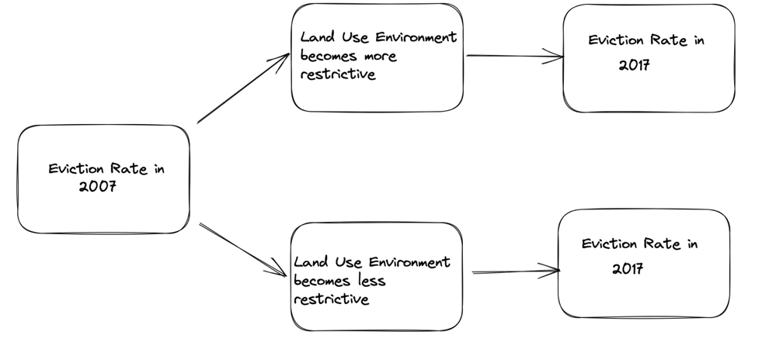

I use the following model to estimate the effects of making housing policy more restrictive compared to states that either made no changes, or states that made housing policy less restrictive:

$$(E_{2017, i}-E_{2007,i})=β_{0}+β_{1}*(X_{2,i}-X_{1,i})+β_{2}*controls+ε_{j}$$

I run a number of regressions using this model with different land-use policy variables. The dependent variable in this model is the difference in the eviction filings rate between 2007 and 2017 for each county *i*. $X$ refers a variety of land use policy indicators. The independent variable in this model is a matrix representing the change in land use policy measures between the years 2003 and 2019 for the Urban Institute dataset, and the years 2007 and 2018 for the Wharton dataset. The coefficient $β_{1}$ indicates the impact of the change in land-use policy on the change in eviction rate in each county.

A chief advantage of using a change-on-change model is that it accounts for time invariant confounders. Nevertheless, time variant confounders may produce omitted variable bias. As my outcome and explanatory variables range from before the Great Recession to after the recession, it is important for me to control for any effect the recession may have had on the demographics of each county. In this model, I control for the change in unemployment rates for the years 2007 and 2017. I use the unemployment rate of a county as a proxy for time variant local economic conditions, which may have changed as a result of the recession. I also control for the change in the percentage of the non-Hispanic white population of a county and the change in the percentage of college-educated adults in a county, as the recession and a ten-year gap, may have changed these demographics. Additionally, several studies have shown a correlation between high eviction filings rates and the percentage of adults that have a college degree[20], the percentage of adults that are white,[21] and the unemployment rate,[22]

**Results**

Table 2 shows a positive correlation between a change in the Wharton Index for a county between the years 2007 and 2017 and the change in the eviction filings rate. According to this table, a one standard deviation increase in the Wharton regulatory index is associated with an increase of 40.810 eviction filings per 100,000 of the population. This coefficient is statistically significant at the 5% level. This result matches our hypothesis that an increase in restrictiveness of land use policy results in an increase in the rate of eviction filings.

In table 2 we can also observe a statistically significant relationship between the change in eviction rate, and a change in the Local Zoning Approval Index (LZAI). This index is based on the results of a series of questions asking city planners which regulatory bodies are required to approve a zoning change. The LZAI is a sum of the number of entities required to approve a change in zoning reform. The addition of a single entity with approval rights in a county is associated with an increase of 30.4 eviction filings per 100,000 households. This relationship is statistically significant at the 5% level. This suggests that when more entities have approval rights, more entities can veto any given development plan. Additionally, an increase in entities with approval rights is associated with an increase time required to obtain an approval. We do not observe statistically significant coefficients on any of the other sub-indicies from this dataset.

Table 3 shows a negative correlation between the legality of mobile homes, and the eviction filings rate in a county. The variables indicating the legality of mobile homes in 2019 and 2003 are dummy variables, with 1 indicating that mobile homes are permitted, and 0 indicating that mobile homes are not permitted. The coefficient here indicates that when a county shifts from allowing mobile homes to not allowing mobile homes, the rate of eviction filings rate increases by 201 per 100,000 of the population. This coefficient is statistically significant at the 1% level. While this was not a variable that I initially considered to have a meaningful impact on the rate of eviction, this result does make sense. It is difficult to regulate mobile homes as thoroughly as single and multi-family homes. Mobile homes also house a disproportionately large percentage of low-income earners. When counties make mobile homes illegal, we observe an increase in the eviction filings rate as the most vulnerable proportion of the population now faces housing insecurity. Another potential why we can observe a strong correlation here could be that mobile homes can be set up and moved away almost instantly. Most land use policies take a while before impacting the housing market at large as constructing houses takes quite a bit of time. However, with mobile homes, it may be possible for us to observe a shift right away.

In table 3, we observe a statistically significant correlation between previously undeveloped land being made available for multi family home construction, and a decrease in the rate of eviction filings. Here we observe that when a county makes more undeveloped available for multi family housing, the eviction filings rate drops by 121.07 per 100,000 of the population. We also observe that for counties for which the supply of multi-family housing increases, on average, the eviction filings rate drops by 157.86 per 100,000 of the population. We also observe that when counties raise fees, on average, the rate of eviction increases by 152.75 per 100,000.

With these results, we observe a general correlation between an increase in restrictiveness of land use policy and an increase in eviction filings. However, these results also raise some interesting questions. For example, why does having more previously undeveloped land available to build multi family homes appear to have a much stronger impact on reduce rates of eviction compared to the same for single family homes? We observe the same trend for housing supply, building multi family housing appears to be significantly more correlated with a greater decrease eviction rate compared to building single family homes. The retrospective question involving housing related fees showed us that an increase in fees is correlated with an increase in eviction filings. However, we do not observe such a statistically significant correlation on our variable for impact fees. This could suggest that while impact fees may not have a strong effect on evictions, other extraneous fees might. We do not observe any statistically significant relationships between the change in inclusionary zoning laws and changes in eviction rates.

**Conclusion**

We find that an increase in land use policy restrictiveness is correlated with an increase in eviction filings in counties across the United States. Our strongest evidence for this is the relationship between a shift in the Wharton Index and an increase in the eviction filings rate. We also observe that increasing the supply of multi-family housing, and making more land available for the construction of multi-family housing is correlated with a decrease in eviction rates. Increases in fees, charges, or proffers for housing permits or construction of civic infrastructure is also correlated with increases in evictions. We, however, do not observe a statistically significant impact of inclusionary zoning on eviction filings. However, we cannot assume that this relationship is absent. Finally, we also observe a very significant correlation between legalizing mobile homes and decreasing evictions.

These findings have important implications for policymakers and practitioners. They suggest that efforts to restrict land use may have unintended consequences, such as increasing rates of eviction. Therefore, policymakers should consider the potential impact of land use policy on housing affordability and access when making decisions.

This study also has several limitations. First, this model of this paper does not allow us to draw a causal inference. However, our findings warrant causal investigations into this relationship. Second, we have a greatly diminished sample size due to a lack of data available for land use policy and evictions. While the NLLUS, the Wharton Residential Land Use Dataset and the Eviction Tracking System are extremely rich in variables and tremendously helpful, they do not have enough coverage to conduct a comprehensive nationwide study. Third, this study observes the relationship between eviction filings and not evictions themselves. It is likely that many of these filings did not actually lead to evictions. Future research should continue to explore the relationship between land use policy and eviction in order to better understand the mechanisms driving this relationship.

**Bibliography**

**Data**

Gyourko, J., Hartley, J., & Krimmel, J. (2019). The Local Residential Land Use Regulatory Environment Across U.S. Housing Markets: Evidence from a New Wharton Index. (No. w26573). National Bureau of Economic Research.

Gyourko, J., Saiz A., and Summers A. (2008). A New Measure of the Local Regulatory Environment for Housing Markets: The Wharton Residential Land Use Regulatory Index, Urban Studies, Vol. 45, Iss. 3, pp. 693-729

Gromis, Ashley, Ian Fellows, James R. Hendrickson, Lavar Edmonds, Lillian Leung, Adam Porton, and Matthew Desmond. Estimating Eviction Prevalence across the United States. Princeton University Eviction Lab. https://data-downloads.evictionlab.org/#estimating-eviction-prevalance-across-us/. Deposited May 13, 2022.

Lydia Lo, Megan Gallagher, Rolf Pendall, Ananya Hariharan, Christopher Davis. National Longitudinal Land Use Survey. The Urban Institute: Washington, DC, 2019. Accessible from: https://datacatalog.urban.org/dataset/national-longitudinal-land-use-sur.... Data developed at the Urban Institute, and made available under the ODC-BY 1.0 Attribution License.

**Literature**

Desmond, M. (2016). Evicted: Poverty and Profit in the American City. New York, NY: Crown Publishers. ISBN: 978-0-553-44743-9. 418 pp.

Coulson, N. Edward and Le, Thao and Shen, Lily, Tenant Rights, Eviction, and Rent Affordability (July 4, 2020). Available at SSRN: https://ssrn.com/abstract=3641859 or <http://dx.doi.org/10.2139/ssrn.3641859>

Abramson, Boaz. 2021. “The Welfare Effects of Eviction and Homelessness Policies.” Stanford University Working Paper. <https://stanford.edu/~boaza/evictions_abramson.pdf>

Schwartz, Heather L., Liisa Ecola, Kristin J. Leuschner, and Aaron Kofner. Tech. Is Inclusionary Zoning Inclusionary? A Guide for Practitioners. Santa Monica, California: RAND, 2012.

Cobb-Clark, Deborah A., Nicolas Herault, Rosanna Scutella, and Yi-Ping Tseng. 2016. “A Journey Home: What Drives How Long People Are Homeless?.” Journal of Urban Economics 91:57–72.

Curtis, Marah, A. Hope Corman, Kelly Noonan, and Nancy E. Reichman. 2013. “Life Shocks and Homelessness.” Demography 50:2227–53.

Desmond, Matthew, and Carl Gershenson. 2017. “Who Gets Evicted? Assessing Individual, Neighborhood, and Network Factors.” Social Science Research 62:362–77.

Desmond, Matthew, and Rachel Tolbert Kimbro. 2015. “Eviction’s Fallout: Housing, Hardship, and Health.” Social Forces 94 (1): 295–324.

Glaeser, Edward L., Joseph Gyourko, and Raven Saks. 2005. “Why Is Manhattan So Expensive? Regulation and the Rise in Housing Prices.” Journal of Law and Economics XLVIII:331–69.

Phinney, Robin, Sheldon Danziger, Harold Pollack, and Kristin Seefeldt. 2007. “Housing Instability among Current and Former Welfare Recipients.” American Journal of Public Health: Research and Practice 97 (5): 832–37.

Maria Hanratty (2017) Do Local Economic Conditions Affect Homelessness? Impact of Area Housing Market Factors, Unemployment, and Poverty on Community Homeless Rates, Housing Policy Debate, 27:4, 640-655, DOI: 10.1080/10511482.2017.1282885

Glaeser, Edward, and Joseph Gyourko. 2018. "The Economic Implications of Housing Supply." Journal of Economic Perspectives, 32 (1): 3-30. DOI: 10.1257/jep.32.1.3

Bento, Antonio, Scott Lowe, Gerrit-Jan Knaap, and Arnab Chakraborty. “Housing Market Effects of Inclusionary Zoning.” *Cityscape* 11, no. 2 (2009): 7–26. http://www.jstor.org/stable/20868701

**Tables**

**Table 1: Summary Statistics**

-----------------------------------------------------------------------------

count mean sd min max

-----------------------------------------------------------------------------

Eviction rate 2000 104 1569.854 3201.01 85.32623 24884.69

Eviction rate 2001 125 1595.635 2795.004 92.33934 22305.61

Eviction rate 2002 158 1497.62 2728.361 84.15737 24357.73

Eviction rate 2003 174 1484.914 2601.704 77.14426 23554.87

Eviction rate 2004 188 1468.002 2471.948 84.15737 22106.81

Eviction rate 2005 190 1516.574 2434.151 78.31311 21598.78

Eviction rate 2006 196 1522.647 2495.425 76.80587 22374.58

Eviction rate 2007 196 1581.576 2636.911 86.49508 23058.89

Eviction rate 2008 195 1617.023 2746.942 89.19391 24174.11

Eviction rate 2009 208 1475.84 2567.251 89.19391 20510.82

Eviction rate 2010 268 1572.851 2576.108 98.1836 23459.62

Eviction rate 2011 269 1603.206 2522.395 127.5968 22977.71

Eviction rate 2012 268 1581.054 2605.812 95.6986 24985.1

Eviction rate 2013 288 1586.841 2518.109 116.4476 23015.25

Eviction rate 2014 286 1583.552 2511.912 125.1192 23940.89

Eviction rate 2015 287 1549.138 2511.213 127.5968 23710.19

Eviction rate 2016 271 1570.1 2538.185 120.164 22584.65

Eviction rate 2017 217 1361.432 2676.884 132.5521 22513.12

Eviction rate 2018 155 998.0793 866.5187 63.17902 5315.474

Change sf amount 220 2.143585 .4592627 1 3

Change sf undev land 220 1.934819 .5810466 1 3

Change sf density 219 2.217909 .4863632 1 3

Change mf amount 217 2.398292 .5285173 1 3

Change mf undev land 218 2.191568 .5668368 1 3

Change fees 220 2.422803 .437552 1.238625 3

Change time required 220 1.880614 .5238188 1 3

Maximum density 2003 281 3.406772 1.115277 1 5

Maximum density 2019 238 3.4056 1.298309 1 5

Maximum density dif 234 -.048092 1.012951 -3.155935 3

Mobile home 2003 288 1.372105 .7265248 0 2

Mobile home 2019 230 .6046506 .4315169 0 1

Mobile home dif 228 -.7468543 .6659642 -2 1

Hypothetical dev 2003 285 1.155054 .5352513 0 2

Hypothetical dev 2019 244 1.211219 .5616404 0 2

Hypothetical dev dif 241 .0356879 .6381176 -2 2

Impact fees 2003 289 .4436161 .4308385 0 1

Impact fees 2019 240 .4885717 .4544556 0 1

Impact fees dif 239 -.0082301 .3800484 -1 1

Inclusionary zoning03 167 .2165887 .3658838 0 1

Inclusionary zoning19 238 .1705062 .3377267 0 1

AH Trust Fund 2003 282 .379337 .494749 0 2

AH Trust Fund 2019 237 .2227087 .3838494 0 1

AH Trust Fund dif 229 -.1866735 .5072712 -2 1

Wharton Index 06 391 -.0577559 .8492323 -1.797917 3.781867

Wharton Index 06 379 -.0806863 .8377161 -1.936406 2.715451

Wharton Index dif 373 -.033302 .9358357 -3.99195 3.09682

LZAI 06 398 2.06478 .883021 0 6

LZAI 18 398 2.809928 1.191791 0 13

LZAI dif 398 .7451484 1.44551 -5 11

SRI 06 397 .1747631 .7067016 0 6

SRI 08 398 .1626655 .6783472 0 6

SRI dif 397 -.0116879 .7923968 -6 6

DRI06 398 .1993028 .3638627 0 1

DRI18 389 1.84562 1.124179 0 4

DRI dif 389 1.644277 1.063105 0 4

OSI06 396 .5616586 .453621 0 1

OSI18 398 .5511461 .4578952 0 1

OSI dif 396 -.0127794 .4923042 -1 1

EI06 394 .7788422 .3757082 0 1

EI18 398 .5015953 .4702666 0 1

EI dif 394 -.2772307 .5220152 -1 1

ADI06 397 5.202207 3.031209 .8485284 16.33333

ADI18 389 5.069319 3.731664 1 24.75

ADI dif 388 -.1491659 3.671909 -14.02778 17.6875

**Table 2**

----------------------------------------------------------------------------------------------------------------------------

m1 m2 m3 m4 m5 m6 m7

b/se b/se b/se b/se b/se b/se b/se

----------------------------------------------------------------------------------------------------------------------------

Wharton Index dif 40.810**

(16.43)

white_dif -250.152 -299.878 -313.975 -450.502 -267.527 -398.532 -299.350

(586.12) (643.20) (650.54) (669.20) (653.74) (661.24) (612.53)

unemp_dif 4215.627** 3843.674 4333.680* 4146.129 4276.926 4041.614 3766.090

(1952.48) (2172.25) (2195.34) (2227.27) (2202.70) (2209.15) (2067.67)

edu_dif -2381.351 -3416.806* -3547.566* -3128.934 -3490.105* -3353.490* -2874.610

(1492.76) (1658.13) (1677.12) (1732.10) (1676.64) (1691.12) (1572.44)

lzai 30.158**

(13.32)

sri 32.474

(23.55)

dri -14.062

(16.08)

osi 31.953

(31.98)

ei -17.372

(30.95)

adi -3.583

(4.70)

_cons 76.846 80.290 111.787* 118.469* 112.767* 98.285 83.788

(45.74) (51.02) (50.50) (57.65) (50.64) (52.68) (47.68)

---------------------------------------------------------------------------------------------------------------------------- * p<0.05, ** p<0.01, *** p<0.001

**Table 3**

------------------------------------------------------------------------------------------------------------

m1 m2 m3 m4 m5 m6

b/se b/se b/se b/se b/se b/se

------------------------------------------------------------------------------------------------------------

Maximum density dif-33.055

(49.86)

white_dif -5009.049** -4627.661** -4764.781** -3188.549* -4501.857 -3179.594*

(1852.81) (1747.35) (1820.08) (1464.11) (5112.51) (1300.84)

unemp_dif 11597.143 11476.773 11020.972 6281.693 3485.391 4159.593

(8921.08) (8619.55) (8825.76) (6994.58) (31586.59) (6309.59)

edu_dif -4368.262 137.309 -4683.089 -6218.170 -13461.206 -2895.652

(6387.96) (5986.90) (6224.31) (4973.54) (24613.07) (4651.09)

Mobile home dif -201.008**

(70.47)

Hypothetical dev dif 42.209

(79.43)

Impact fees dif 34.169

(114.62)

AH Fee_dif 238.968

(260.74)

AH Trust Fund dif 18.505

(67.22)

_cons -55.043 -296.499 -34.658 -4.721 -140.840 -86.577

(221.12) (214.55) (215.90) (171.57) (630.13) (160.54)

------------------------------------------------------------------------------------------------------------

p<0.05, ** p<0.01, *** p<0.001

**Table 4**

----------------------------------------------------------------------------------------------------------------------------

m1 m2 m3 m4 m5 m6 m7

b/se b/se b/se b/se b/se b/se b/se

----------------------------------------------------------------------------------------------------------------------------

Change sf amount -63.715

(81.87)

white_dif -3566.538* -3464.741* -3667.179* -3859.640** -3538.587* -3036.404* -3442.049*

(1459.32) (1460.94) (1455.99) (1455.69) (1441.60) (1466.70) (1443.62)

unemp_dif 4289.315 4780.055 4283.655 2536.461 3970.085 5066.107 5046.522

(7283.82) (7391.32) (7192.15) (7225.81) (7155.80) (7120.56) (7129.21)

edu_dif -4102.117 -4180.017 -3534.329 -4117.446 -4654.191 -4581.931 -5139.801

(5288.00) (5303.60) (5284.94) (5226.06) (5245.25) (5244.61) (5282.52)

Change sf undev land -17.254

(66.92)

Change sf density -106.770

(83.82)

Change mf amount -157.860**

(76.73)

Change mf undev land -121.705*

(72.46)

Change fees 152.749*

(92.05)

Change time required 119.111

(75.56)

_cons 22.245 -68.780 107.669 222.317 152.334 -445.042 -299.566

(239.76) (218.71) (242.97) (237.75) (233.79) (274.20) (219.28)

----------------------------------------------------------------------------------------------------------------------------p<0.05, ** p<0.01, *** p<0.001

**Table 5**

| WRLURI~f lzai sri dri osi ei adi

-------------+---------------------------------------------------------------

WRLURI_diff | 1.0000

lzai | 0.2357 1.0000

sri | 0.1713 0.0598 1.0000

dri | 0.0267 0.0803 0.0534 1.0000

osi | 0.2626 -0.0164 0.0009 -0.0882 1.0000

ei | 0.1702 0.0574 0.0622 0.1698 0.0876 1.0000

adi | 0.2583 -0.0437 0.0133 0.0001 0.0105 0.0266 1.0000

**Table 6**

| sf_amt sf_undev sf_density mf_amt mf_undev fees time_req

-------------+---------------------------------------------------------------

Change sf amount | 1.0000

Change sf undev land| 0.6274 1.0000

Change sf density | 0.1438 0.1048 1.0000

Change mf amount | 0.1478 0.1167 0.2856 1.0000

Change mf undev land| 0.2149 0.3324 0.1608 0.6368 1.0000

Change fees | -0.0803 -0.1086 0.0062 -0.0046 -0.1194 1.0000

Change time required| -0.0154 -0.0256 -0.0679 0.0911 0.0287 0.1117 1.0000

**Table 7**

| maxden~f mobhom~f hypode~f ifyn_dif afincl~f ah_tf_~f

-------------+------------------------------------------------------

Maximum density dif | 1.0000

Mobile home dif | 0.1985 1.0000

Hypothetical dev dif | -0.0111 0.1905 1.0000

Impact fees dif | 0.1092 0.0995 -0.0965 1.0000

Inclusionary Zoning | 0.0358 0.1860 0.0271 -0.0817 1.0000

AH Trust Fund dif | 0.0649 0.0990 -0.0086 0.0252 0.0446 1.0000

**Maps**

**Map 1: Wharton Index in 2007**

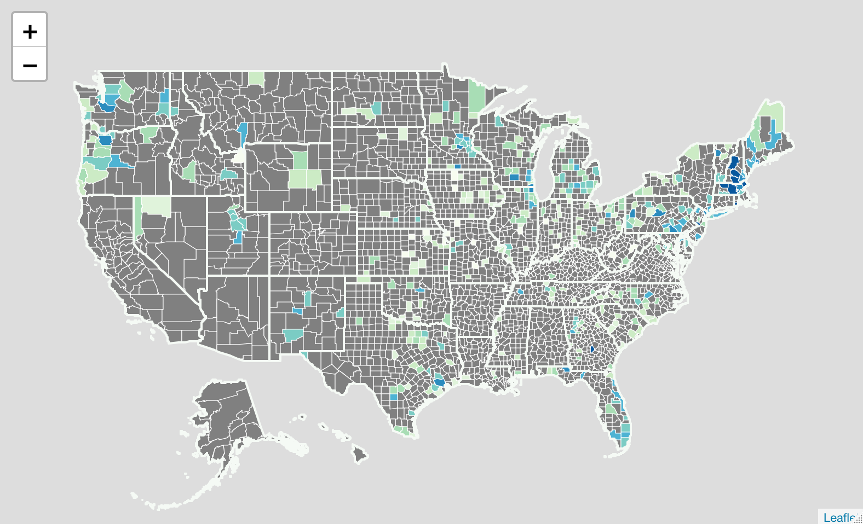

**Map 2: Wharton Index in 2017**

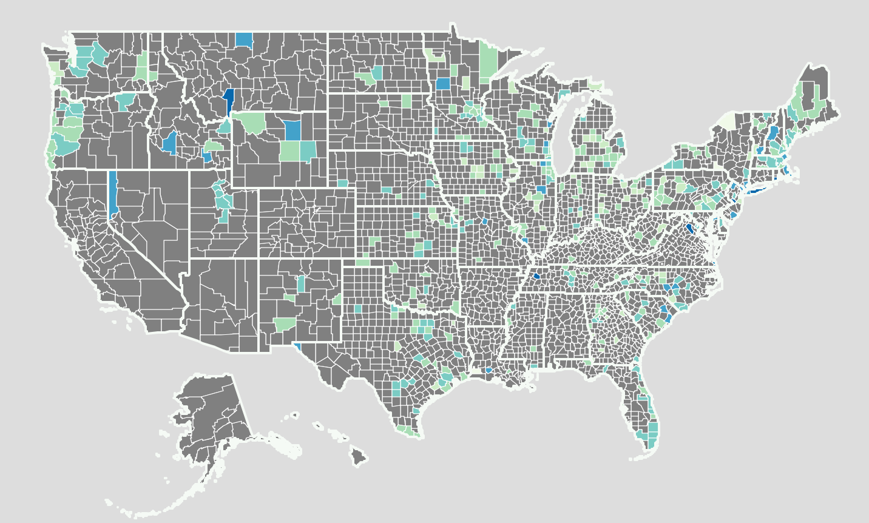

**Map 3: Difference in Wharton Index (2007-2017)**

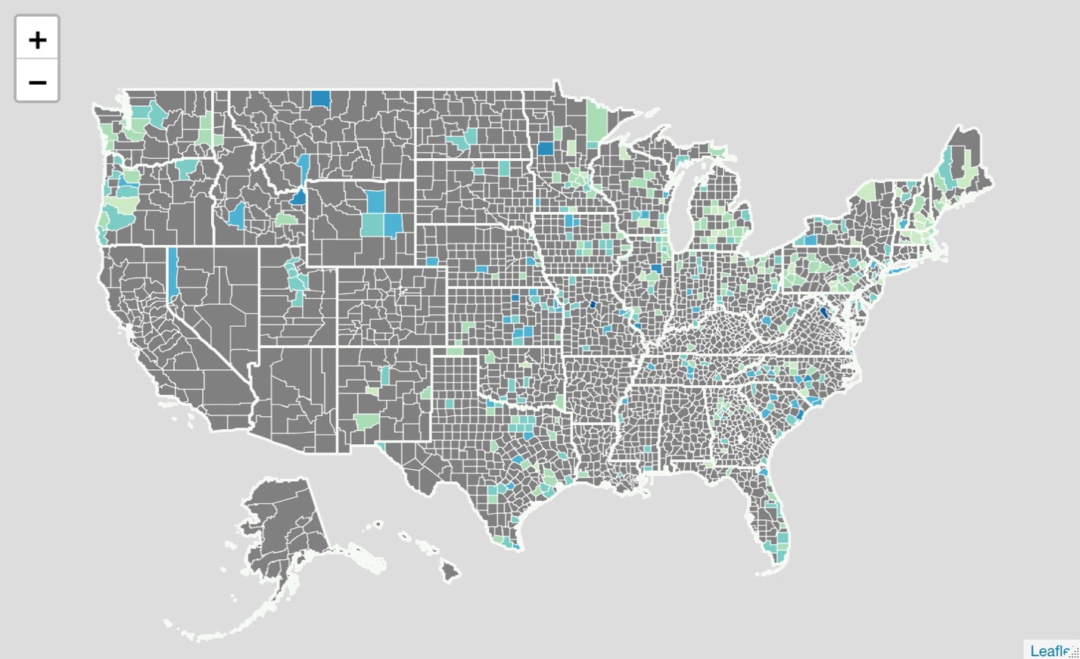

**Map 4: Eviction Filings per 100,000 (2007)**

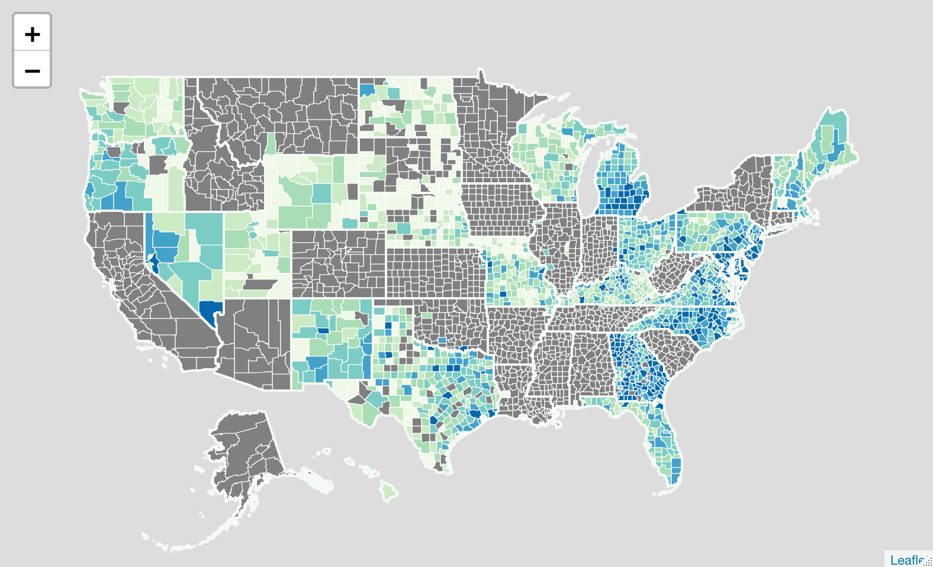

**Map 5: Eviction Filings per 100,000 (2017)**

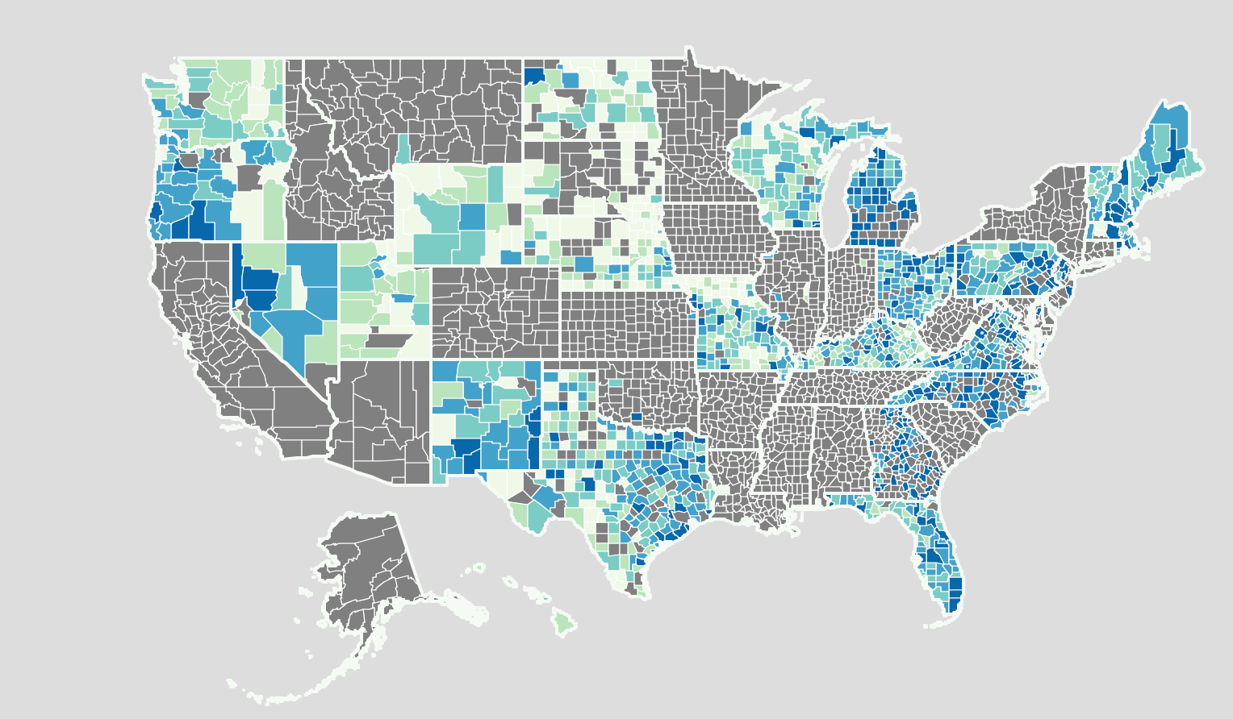

**Map 6 Difference in Eviction Filings per 100,000 (2007-2017)**

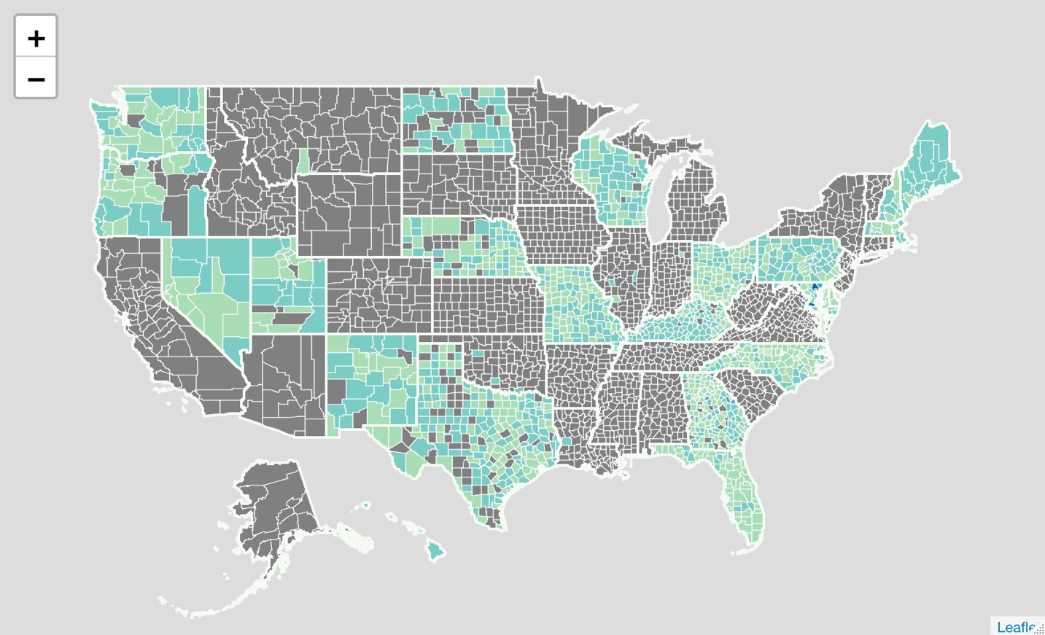

1. I am immensely grateful to Professor Will Pyle for advising me on this thesis.
2. Gromis et al., 2022
3. Desmond, 2016.
4. Jardim, et al., 2017.
5. Desmond, 2012.
6. Humphries et al., 2019.
7. US Government Accountability Office 20-247 (2020)
8. American Housing Survey, 2000–2017
9. Hepburn et al. (2020)
10. Phinney et al. (2007)
11. Curtis et al. (2013)
12. Johnson et al. (2005)
13. Cobb-Clark et al. (2016)
14. Coulson et. al (2020)
15. Schwartz et al. (2012)
16. Bento et al. (2009)
17. Dawkins, 2022.
18. Hanratty, 2017.
19. Glaeser and Gyourko, 2018.
20. Phinney et al. (2007)
21. Hepburn et al. (2020)
22. Johnson et al. (2005)